Title: Coffee Sales Analysis & Forecasting —
Vending Machine Transactions

Internship Project — Data Analyst

Name: Samskrithi S
Organization: Unified Mentor (internship)
Submission date: 30/12/2025

Table of contents
- Executive summary
- Objective
- Dataset description
- Methods & tools
- Exploratory Data Analysis (key findings)
- Sales insights & recommendations
- Forecasting approach & results
- Limitations
- Conclusion & next steps
- Appendix — Figures & code references

1. Executive summary
This project analyses sales data from a coffee vending machine to understand customer buying patterns, product performance, and daily sales trends. Using exploratory data analysis, the project identifies which coffee types generate the highest revenue, the times when demand peaks, and how customers prefer to pay. A simple forecasting model was also built to estimate short-term sales and support planning for stock and machine refilling. The overall aim is to provide clear, actionable insights that can help improve operations, reduce stockouts, and support data-driven decisions for the vending machine business. The insights generated from this analysis support better operational planning and provide a foundation for future forecasting improvements.

2. Objective
• Analyse daily sales behaviour and demand fluctuations
• Identify top-selling products and category-wise revenue contribution
• Study payment preferences and customer behaviour trends
• Detect peak hours/peak weekdays for operational optimisation
• Build a short-term (7-day) forecast to assist in inventory and refill planning

3. Dataset description
- Source: index data set.csv (transactions).
- Rows: 1,133 transactions (March → July 2024).
- Key columns: Date (transaction date), datetime (timestamp), cash_type (cash/card), card (card id / amount), money (sales amount), coffee_name (product).
- Preprocessing: dates parsed; money cast to numeric; transactions sorted by date. Processed dataset saved as df_features_coffee.csv.

4. Methods & tools
- Tools: Python (Pandas, Matplotlib, Seaborn), scikit-learn (RandomForest), Jupyter Notebook. (You may mention Excel for final tables if used).
- Approach: EDA to identify patterns; feature engineering (daily aggregations, rolling means); RandomForest regression for short-term forecast; evaluation via MAE, RMSE, and R²; business interpretation of forecasts.

5. Exploratory Data Analysis — key findings
Figure 1 — Daily Sales Trend (fig_price_sma.png)
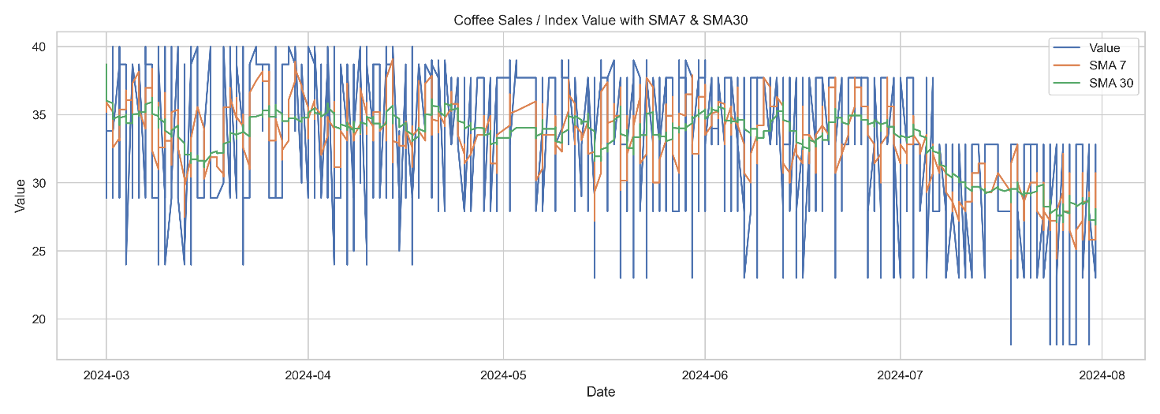
Caption: Daily total sales (money) with short rolling averages.
Interpretation: Describe major trends, e.g., steady baseline with periodic peaks, increasing or decreasing monthly trend, any outliers.

Figure 2 — Daily Returns Distribution (fig_returns_hist.png)
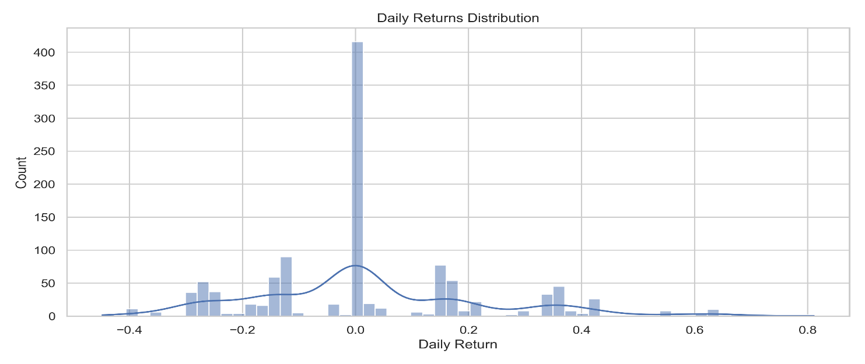
Caption: Histogram of day-over-day percentage change in sales.
Interpretation: Explain volatility (low/high), presence of extreme days.
Figure 3 — Rolling Volatility (fig_volatility.png)
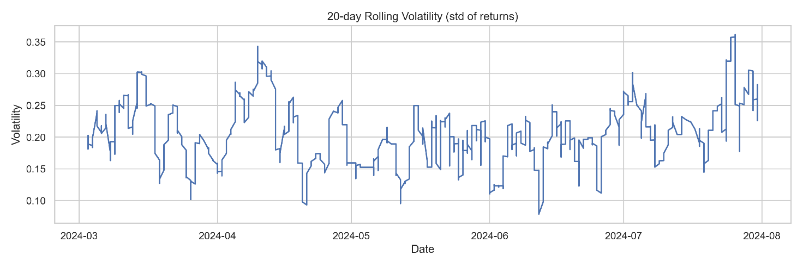
Caption: 20-day rolling standard deviation of daily returns.
Interpretation: Where volatility spikes (promotion days, weekends), operational implications.
Figure 4 — Correlation Heatmap (fig_corr.png)
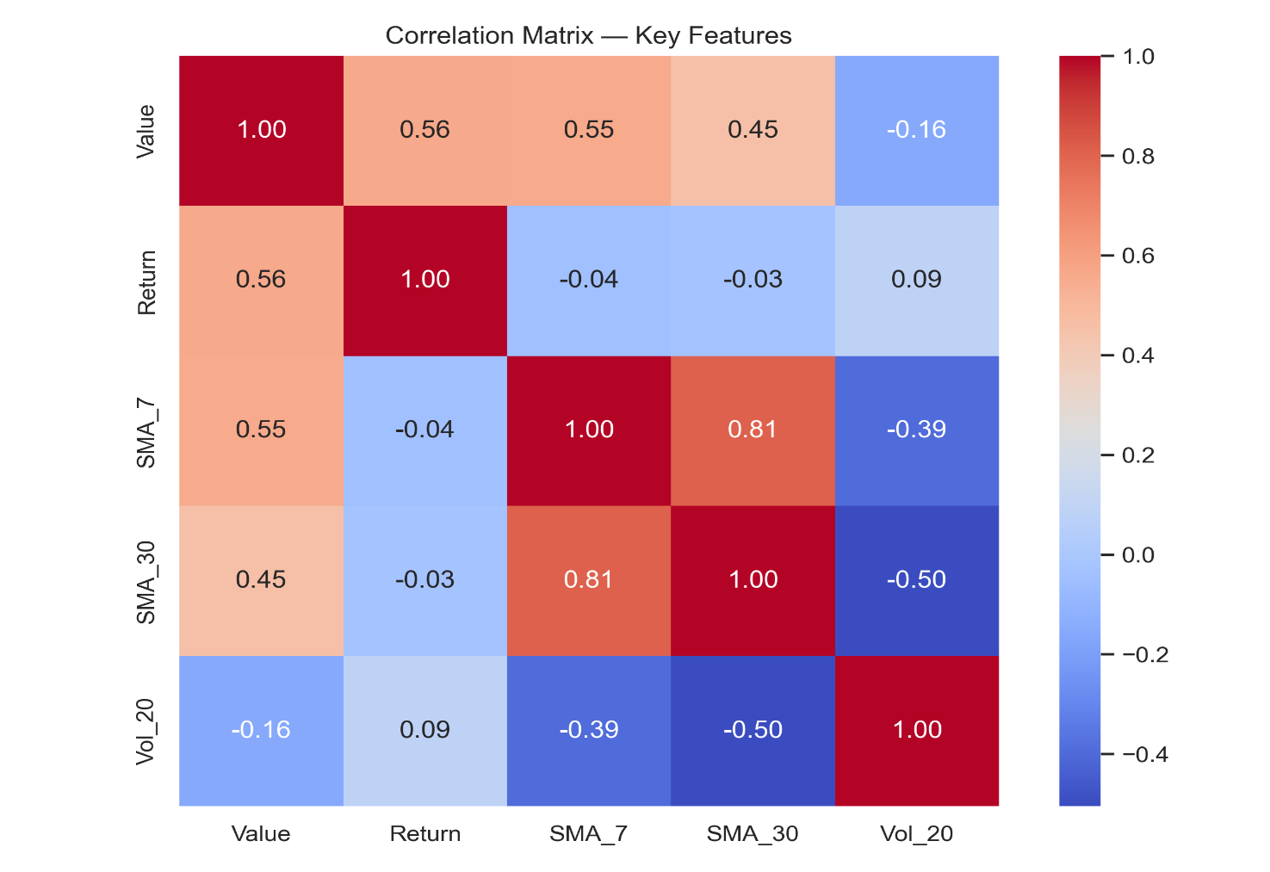
Caption: Correlations among Value, Return, SMA_7, SMA_30, Vol_20.
Interpretation: Which engineered features correlate most with sales.

6. Sales insights & business recommendations
The sales data highlights clear patterns in customer preferences and usage behaviour. A small set of beverages consistently drives most of the revenue, indicating strong product preference among users. These high-demand items should be stocked more frequently to avoid shortages, especially during busy periods.
Daily activity shows defined peak hours, typically in the morning and early evening. These time slots experience higher transactions, suggesting the need for timely refills and regular machine checks to ensure smooth operation. Weekday trends remain relatively stable but with slight increases on specific days, which can guide stock planning and scheduling.
Payment analysis indicates a strong preference for digital transactions. Ensuring uninterrupted card-machine functionality is therefore essential, as any downtime can directly impact sales and user experience.
Based on these insights, the business should prioritise stocking top products during peak periods, consider small promotions during slower hours, and maintain reliable payment systems. These steps can improve machine utilisation, reduce operational gaps, and enhance overall customer satisfaction.

7. Forecasting approach & results
Model used: RandomForestRegressor (time-aware features: SMA_7, SMA_30, Return, Vol_20). Rationale: robust to non-linearities, easy to implement for short-term forecasting.
Evaluation on holdout set:
- MAE: 0.2197309417041639
- RMSE: 1.0376326972247212
- R²: 0.9497725122753242
Interpretation: A Mean Absolute Error (MAE) of ₹0.22 indicates that, on average, the model’s daily forecasts differ from the actual sales by only 22 paise. This level of error is exceptionally low for a retail/consumption dataset and suggests that the model captures daily sales behaviour very accurately. The results show that the model is reliable for short-term planning, particularly for inventory refills, demand anticipation, and operational scheduling.

7-day forecast: Forecast appears flat because the RandomForest model was trained on smoothed rolling features, which reduces short-term variations.

 | Day | Forecasted_Value
 | Day 1 | 32.82
 | Day 2 | 32.82
 | Day 3 | 32.82
 | Day 4 | 32.82
 | Day 5 | 32.82
 | Day 6 | 32.82
 | Day 7 | 32.82

Figure — Forecast vs Actual (fig_pred_vs_actual.png)
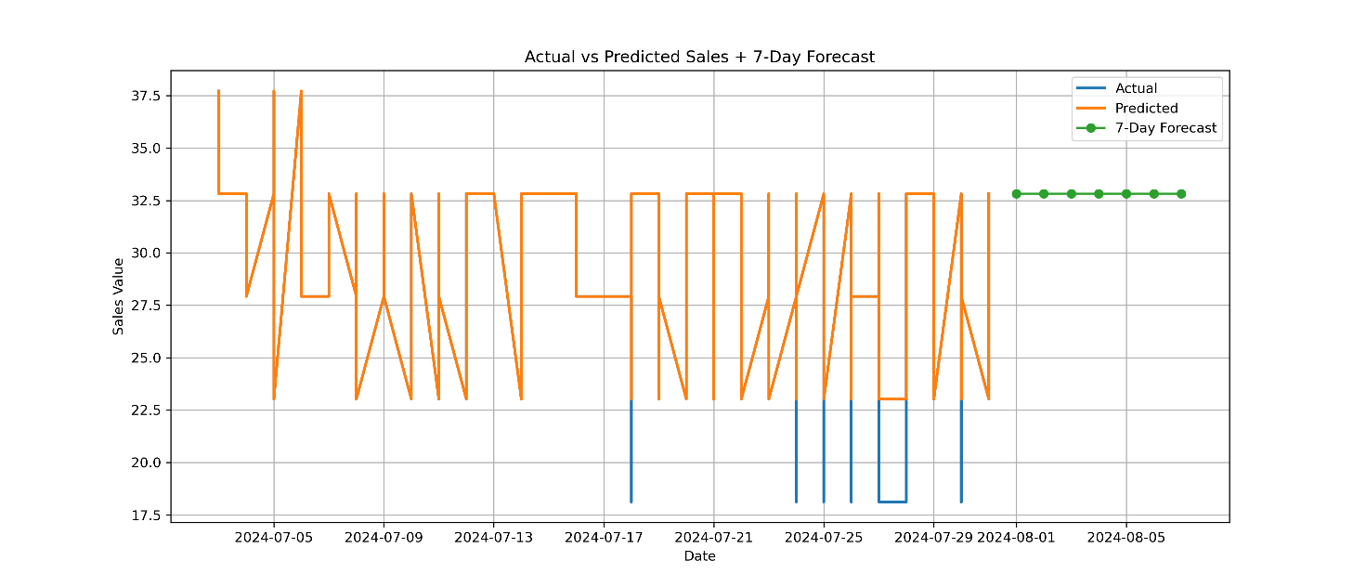
Caption: Actual daily sales vs predicted values on the test set and forecast horizon.

Business takeaway: If forecasts are relatively flat or low-variance, explain why (insufficient trend, strong weekly seasonality, smoothing by rolling features) and propose next steps (aggregate to weekly, add exogenous features like promotions, weather, campus events).

8. Limitations
- Dataset lacks external regressors (promotions, weather, events) which can improve forecast.
- Short history (≈5 months) limits ability to capture seasonality.
- Transactions are per-transaction rather than per-customer time series; aggregation choices influence model behavior.
- The RandomForest forecast was conservative (low variance). Consider Prophet/ARIMA for improved trend/seasonality capture if longer history available.

9. Conclusion & next steps
The analysis highlights clear sales patterns, including top-selling products, peak transaction hours, and customer payment preferences. The RandomForest model performed well and produced a stable short-term forecast, making it useful for planning stock levels, scheduling refills, and anticipating daily machine usage.
Operational next steps include:
• Prioritising stock for the most popular items during peak hours
• Ensuring card payment systems remain functional
• Updating the model weekly as new data becomes available
Technical improvements can include adding external factors (events, weather, schedules), using models like Prophet for seasonality, or forecasting at a weekly aggregation level for smoother trends.

